Application Form
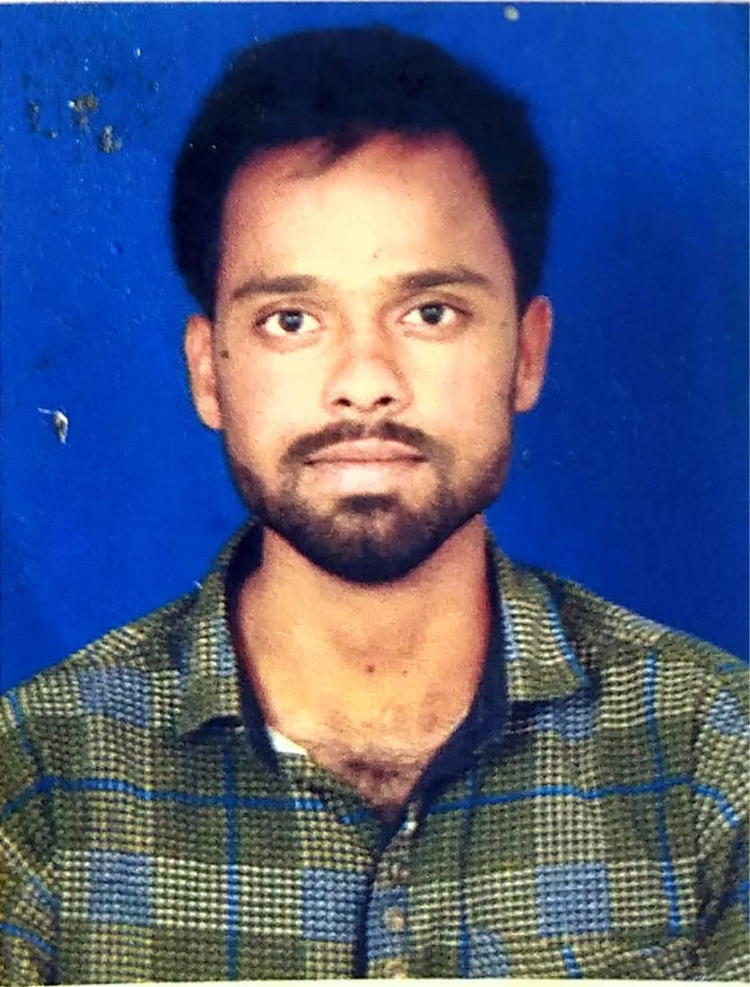
Please Affix Your Passport Size Photograph

Please fill in the details with utmost attention, as these shall be verified by HCL Technology Limited
and/ or by its authorized representatives.

All details are compulsory.

Personal Details
Full Name of Applicant: ASHOK BUMALLA

HCL SAP Code: 52086150

HCL Official Email id: bumallaashok.b@hcl.com

HCL Office Address: HCL Technologies Ltd, SAL (602), 6th Floor, Tower 4, Special Economic Zone (SEZ), 129,
Jigani Industrial Area, Bommasandra-Jigani Link Road, Bangalore – 562 106

Date of Birth (dd/mm/yy): 27/02/1994 |  | Place of Birth: Karimnagar
Sex: Male |  | Nationality: Indian
Father’s Name: ILAIAH |  | Passport No.: NA
Home Phone: 9392104237 | Office Phone: | Mobile: 8919052774

Residential Addresses
Permanent Address: H.No: 1-41, Vill: Gundaram, Mdl: Bejjanki, Dist: Siddipet State: Telangana, Pincode: 505528

City: Siddipet | State: Telangana |  | Pin Code: 505528 | Phone No.: 8919052774
Duration of Stay: From (01/2000) To (06/2022) |  | Nature of location: Rented Own Other (Specify)
Landmark: Near Primary School, H.No: 1-41, Vill: Gundaram, Mdl: Bejjanki, Dist: Siddipet State: Telangana, Pincode: 505528

Current Address:

City: Siddipet | State:Telangana |  | Pin Code: 505528 | Phone No.: 8919052774
Duration of Stay: From (01/2000) To (06/2022) |  | Nature of location: Rented Own Other (Specify)
Landmark: Near Primary School, H.No: 1-41, Vill: Gundaram, Mdl: Bejjanki, Dist: Siddipet State: Telangana, Pincode: 505528.

Address History:

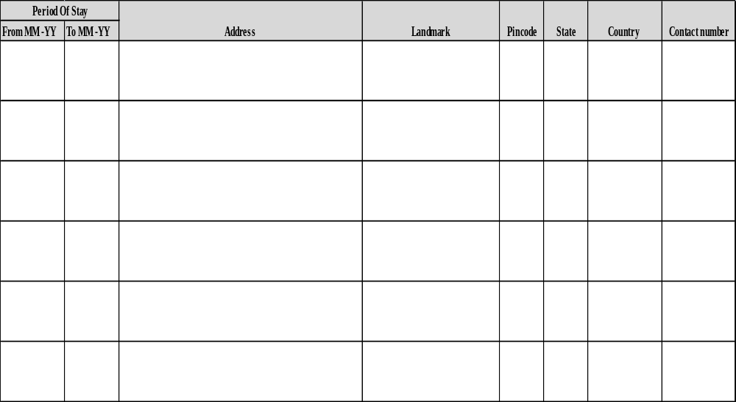

Education Details
Qualification | Name & Address Of School / College/ Institute | Name & Address of  Board / University  to which the School / College / Institute  is affiliated to | Course Attended  (Morning/ Evening/ Correspondence) | Marks (%) CGPA  &  Class | Dates Attended |  | Roll Number/ Registration Number/ Exam Seat Number
 |  |  |  |  | Year of enrolment (mm/yy) | Year Passed (mm/yy) | Roll Number/ Registration Number/ Exam Seat Number
Graduation | Sree Chaitanya Institute of Technological Sciences. | JNTUH | CORRESPONDENCE | 66 | 06/2011 | 05/2015 | 11TR1A0216
Degree:

Discipline:

Full Time

Part time
Distance learning course

Post Graduation | NA
Degree:

Discipline:

Full Time

Part time

Distance learning course

Any Other | NA

Employment Record: Starting with your present or most recent employer, please list last 5 employments. When listing consulting or temporary assignments, under “Employer”, state the name of the consulting or temporary agency that placed you at the client site. Complete and accurate dates (month/year) must be provided.

EMPLOYER 1: ATHEXA INFOSOLUTIONS |  | Employee Id: AIS-5761 | From (03/2019): |  |  | To (05/2022):
Street Address: Plot No D-5, Road No 20, Marol MIDC, Andheri East,Mumbai- 400093. |  |  | Employer’s  Phone No.: 022 6849330 |  |  |  | Fax No.:
City: Mumbai | State: Maharastra | Country: India |  |  | Postal Code: 400093
Job Title: AWS DevOps Engineer |  | Reason for leaving: Career Growth
Employment Status: (Please check the relevant box)  Full Time  Contract /Through Outsourcing Agency  Outsourcing Agency Details:  Name:  Address:  Tel No.: |  | Supervisor’s Details:
 |  | Name: |  | Aravind D
 |  | Title: |  | Reporting Manager
 |  | Phone No.: |  | 022 6849330
 |  | E-mail id:  (Preferably official) |  | aravind.d@athexa.in
 |  | HR Manager’s Details:
 |  | Name: |  | Neha G
Description of Duties: |  | Phone No.: |  | 022 6849330
 |  | E-mail id:  (Preferably official) |  | Neha.g@athexa.in

EMPLOYER 2: |  | Employee Id: | From (mm/yy): |  |  | To (mm/yy):
Street Address: |  |  | Employer’s  Phone No.: |  |  |  | Fax No.:
City: | State: | Country: |  |  | Postal Code:
Job Title: |  | Reason for leaving:
Employment Status: (Please check the relevant box)  Full Time  Contract /Through Outsourcing Agency  Outsourcing Agency Details:  Name:  Address:  Tel No.: |  | Supervisor’s Details:
 |  | Name:
 |  | Title:
 |  | Phone No.:

E-mail id:

(Preferably official)
 |  | HR Manager’s Details:
 |  | Name:
Description of Duties: |  | Phone No.:

E-mail id:
(Preferably official)

EMPLOYER 3: |  | Employee Id: | From (mm/yy): |  |  | To (mm/yy):
Street Address: |  |  | Employer’s  Phone No.: |  |  |  | Fax No.:
City: | State: | Country: |  |  | Postal Code:
Job Title: |  | Reason for leaving:
Employment Status: (Please check the relevant box)  Full Time  Contract /Through Outsourcing Agency  Outsourcing Agency Details:  Name:  Address:  Tel No.: |  | Supervisor’s Details:
 |  | Name:
 |  | Title:
 |  | Phone No.:

E-mail id:

(Preferably official)
 |  | HR Manager’s Details:
 |  | Name:
Description of Duties: |  | Phone No.:

E-mail id:
(Preferably official)

EMPLOYER 4: |  | Employee Id: | From (mm/yy): |  |  | To (mm/yy):
Street Address: |  |  | Employer’s  Phone No.: |  |  |  | Fax No.:
City: | State: | Country: |  |  | Postal Code:
Job Title: |  | Reason for leaving:
Employment Status: (Please check the relevant box)  Full Time  Contract /Through Outsourcing Agency  Outsourcing Agency Details:  Name:  Address:  Tel No.: |  | Supervisor’s Details:
 |  | Name:
 |  | Title:
 |  | Phone No.:

E-mail id:

(Preferably official)
 |  | HR Manager’s Details:
 |  | Name:
Description of Duties: |  | Phone No.:

E-mail id:
(Preferably official)

EMPLOYER 5: |  | Employee Id: | From (mm/yy): |  |  | To (mm/yy):
Street Address: |  |  | Employer’s  Phone No.: |  |  |  | Fax No.:
City: | State: | Country: |  |  | Postal Code:
Job Title: |  | Reason for leaving:
Employment Status: (Please check the relevant box)  Full Time  Contract /Through Outsourcing Agency  Outsourcing Agency Details:  Name:  Address:  Tel No.: |  | Supervisor’s Details:
 |  | Name:
 |  | Title:
 |  | Phone No.:

E-mail id:

(Preferably official)
 |  | HR Manager’s Details:
 |  | Name:
Description of Duties: |  | Phone No.:

E-mail id:
(Preferably official)

Professional References:

Reference Name | Reference Mobile Number | Company name | Reference official number

Information Release Authorization
- I certify that the statements made in this application are valid and complete to the best of my knowledge. I understand that false or misleading information may result in termination of employment.

- If upon investigations, any of this information is found to be incomplete or inaccurate, I understand that I will be subject to dismissal at any time during my employment.

- I hereby authorize HCL Technologies and/or any of its subsidiaries or affiliates and any persons or organizations acting on its behalf (TP --------------------------.), to verify the information presented on this application form and to procure an investigative report or consumer report for that purpose.

- I hereby grant authority for the bearer of this letter to access or be provided with full details of my previous records. In addition, please provide any other pertinent information requested by the individual presenting this authority.

- I hereby release from liability all persons or entities requesting or supplying such information.

- I authorize HCL Technology Ltd. to contact my previous employer. Yes No

- I have read, understand, and by my signature consent to these statements.

Signature:    Name (In Block Letters): ASHOK BUMALLA | Date: 07/06/2022

Documents checklist

Application Form:
- Duly signed application form

Education Verification:

- Photocopy of degree certificate and all years / semesters marks sheets
- Photocopy of provisional degree certificate required for courses completed in the last 6 months from the current date

Employment Verification:

- Photocopy of relieving certificate, service certificate, latest salary slips & offer letter
- Resignation acceptance letter is required in case full & final settlement is pending with employer

Address Verification:
- Address proof would be required (Copy of passport, driving license, utility bills, rental agreement or lease agreement)

Criminal verification:
- One photo id proof (Copy of passport, PAN card or voters ID)
- Address proof would be required (Copy of passport, driving license, utility bills, rental agreement or lease agreement)
- CID form (Demand draft of INR 100 mentioned in the form is not required)

Identity verification:
- Copy of valid passport and PAN card required

